Git and github challenges
Resolve Merge Conflicts
Create a merge conflict intentionally (two users editing the same line).
Creating and initializing a repository.
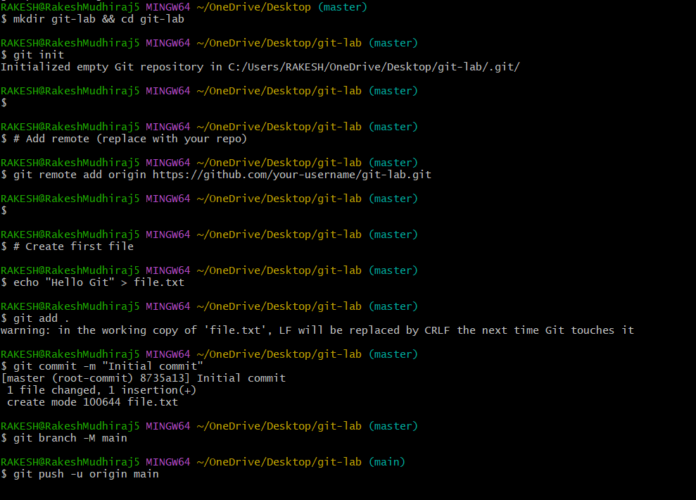
Here we have created a new file and added text in that.
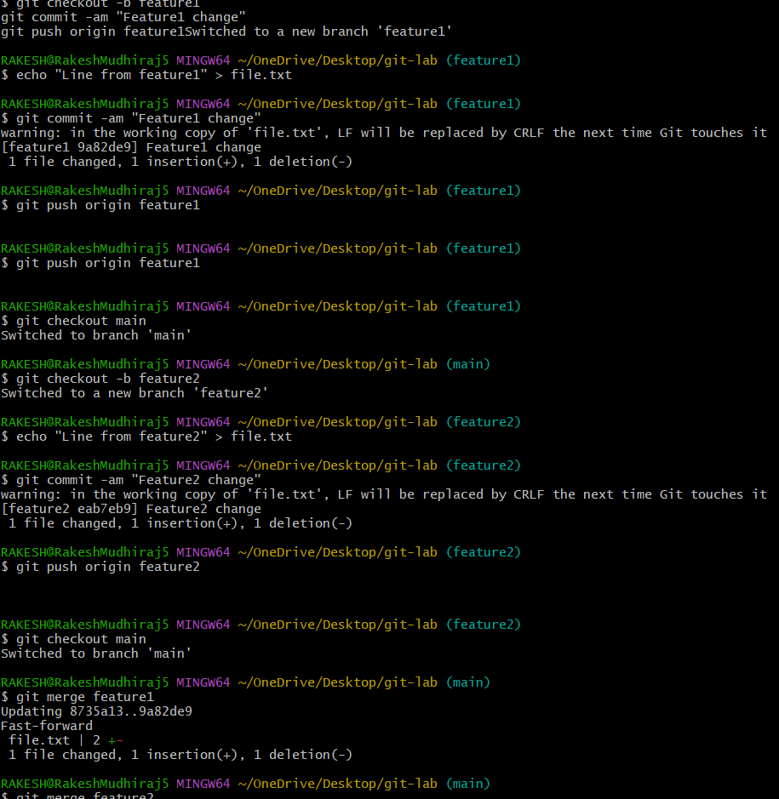

- Resolve the conflict and push the changes.
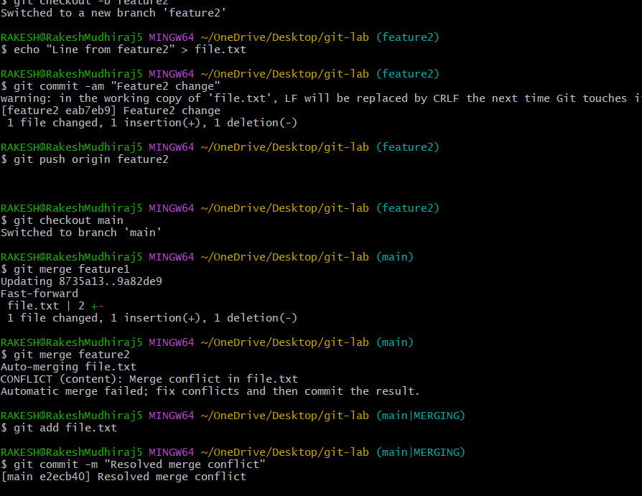

- Recover Deleted Branch
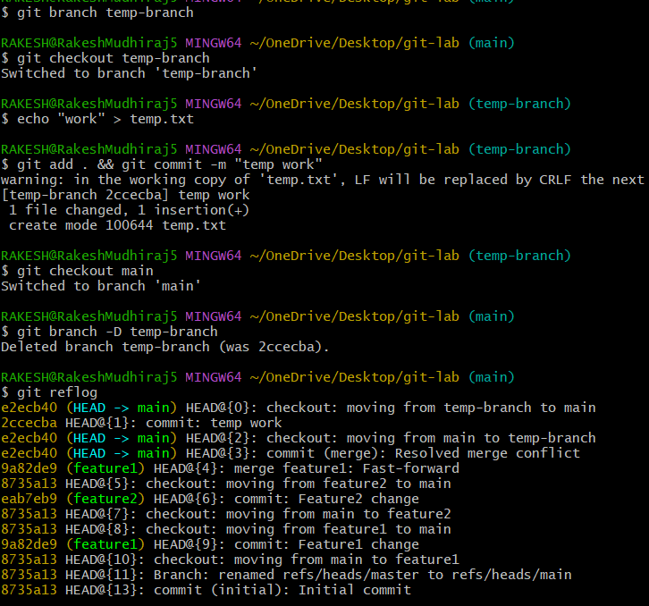
- Delete a local branch and then recover it using the reflog.


- Undo Wrong Push
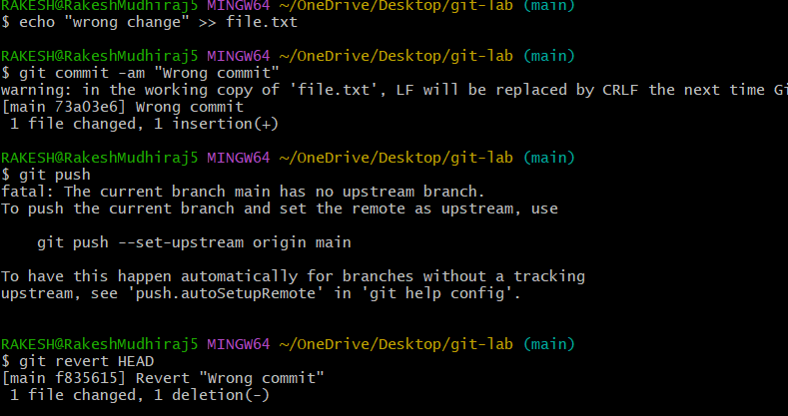
- Push a wrong commit to GitHub, then undo it without losing history.
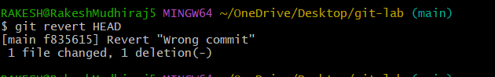
Amend a Commit
Make a commit, then add a missing file to it using git commit --amend.
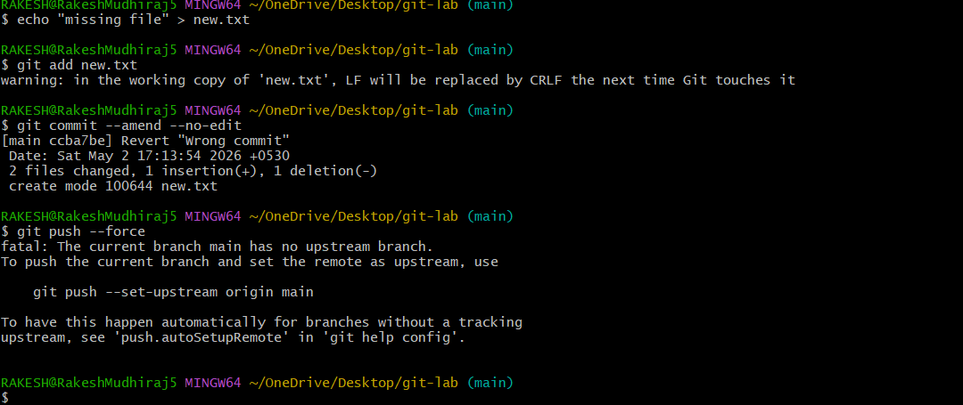
Cherry-pick a Commit
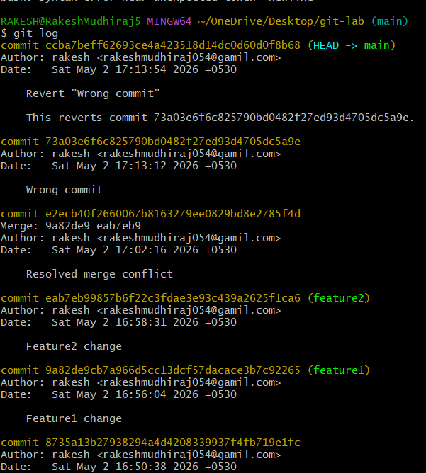
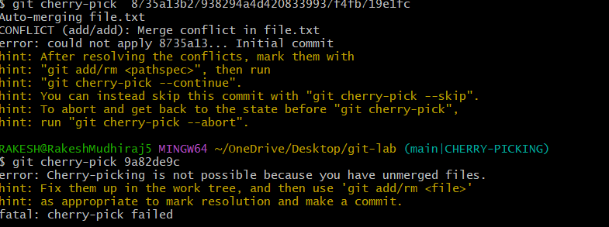
Take a specific commit from one branch and apply it to another branch.

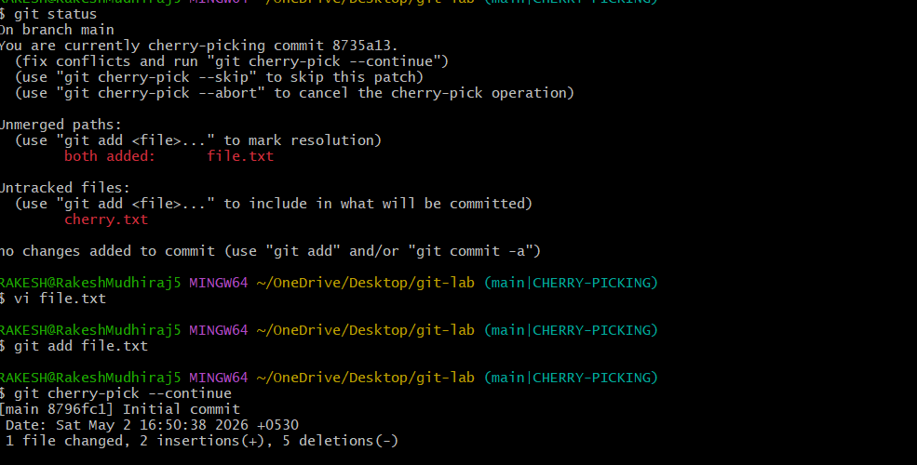
Interactive Rebase
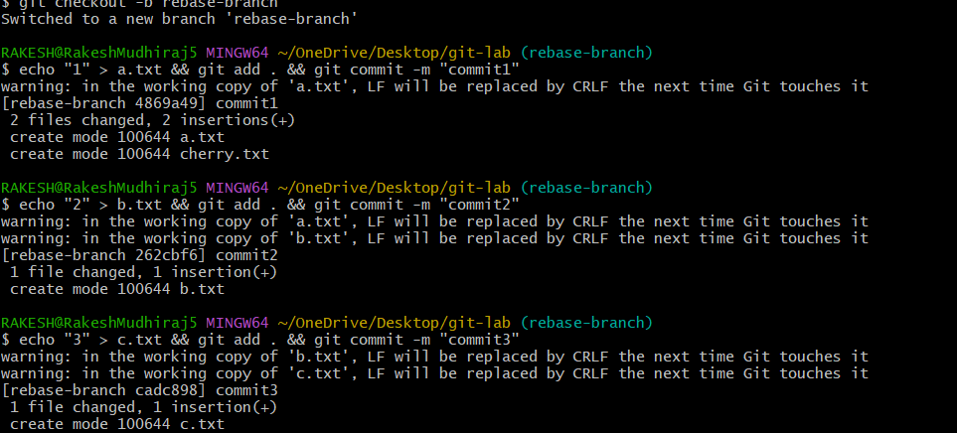

Reorder and squash multiple commits into a single clean commit.

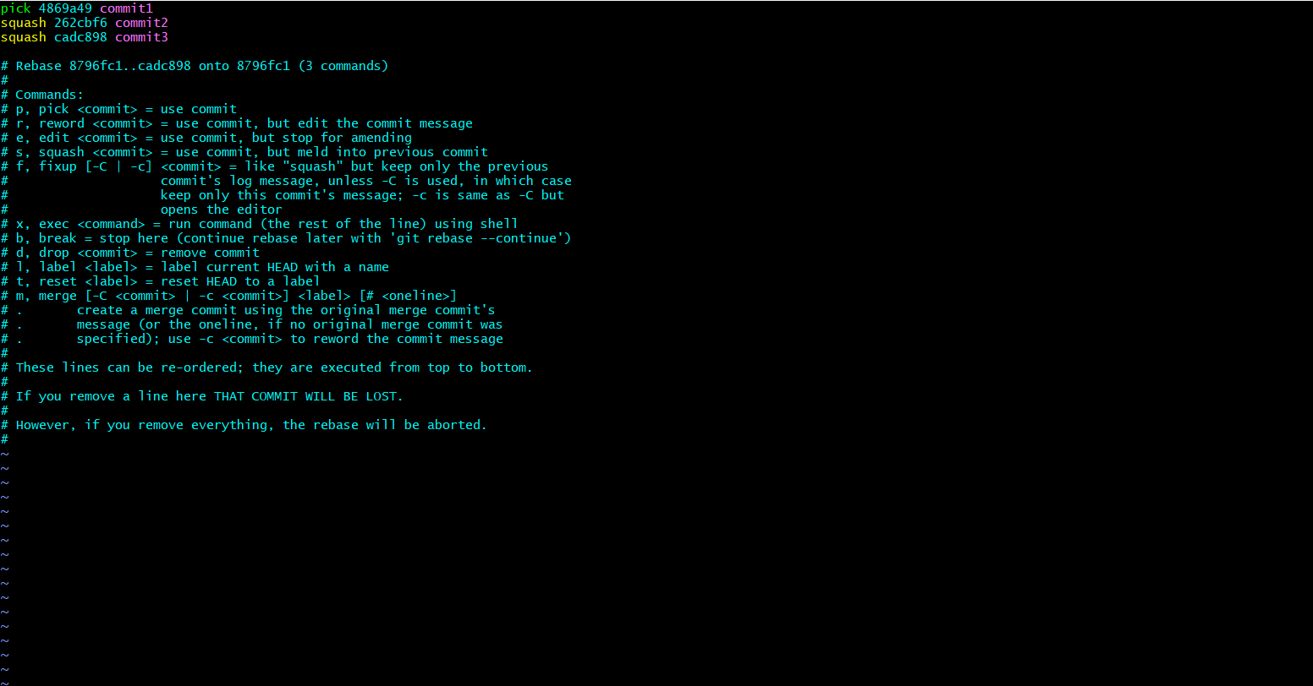
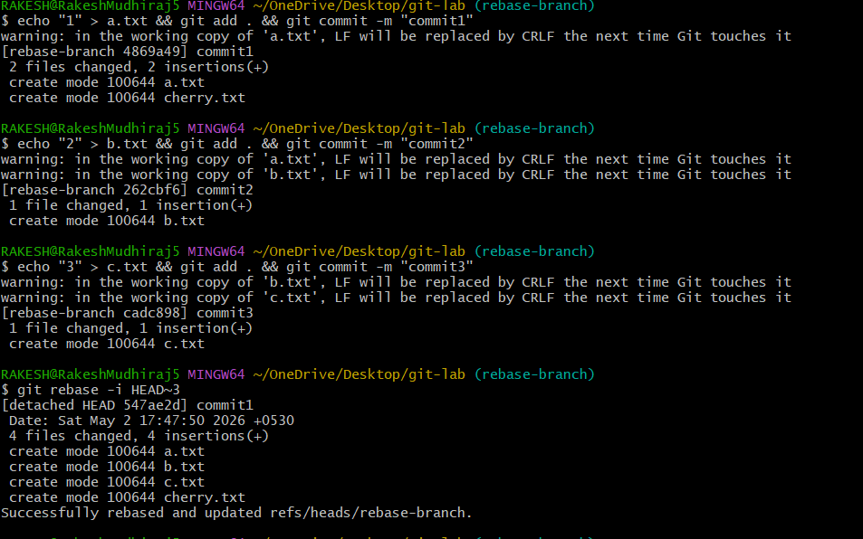

Tagging & Release
Create a version tag (v1.0), push it to GitHub, then delete and restore it.
Clone with Sparse Checkout
Clone only a subdirectory of a repo using sparse checkout.
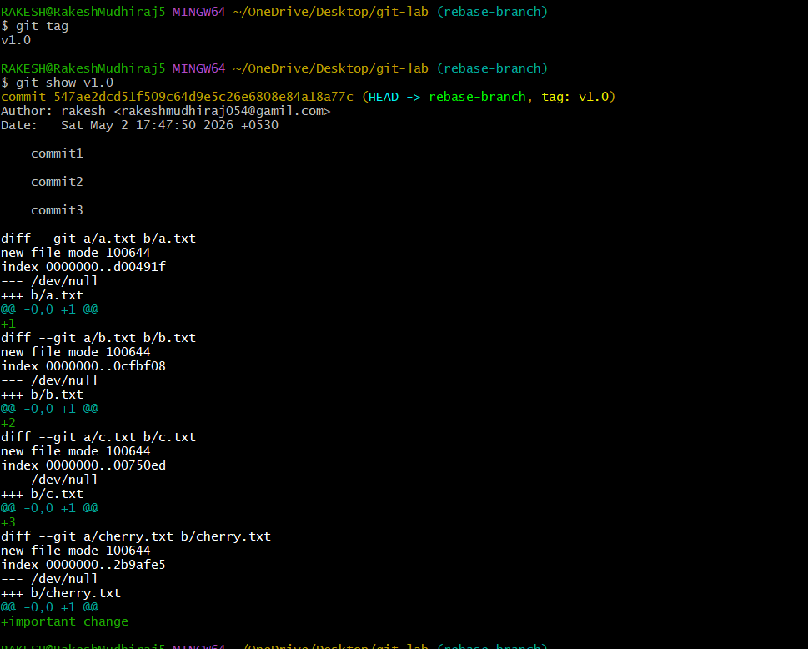
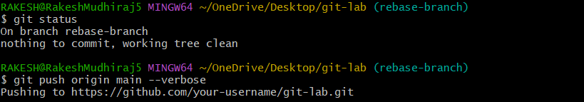
Reset vs Revert Challenge

- Demonstrate the difference between git reset --hard and git revert in a repo.
- Detached HEAD Challenge
- Checkout a specific commit (detached HEAD state) and create a new branch from it
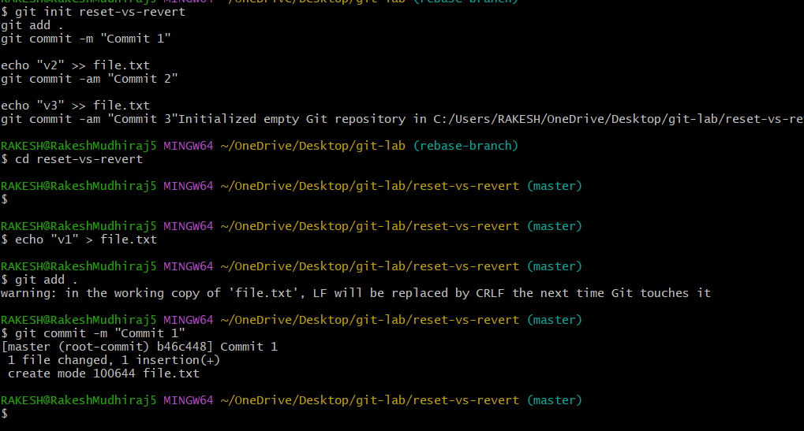
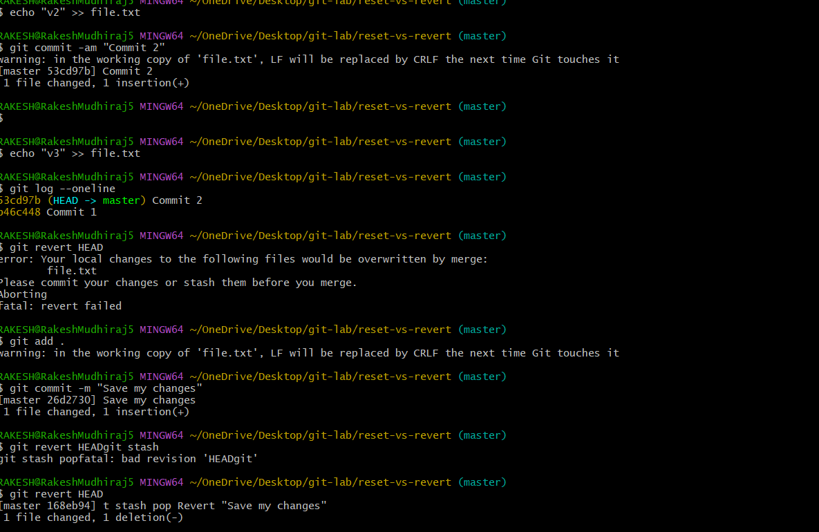
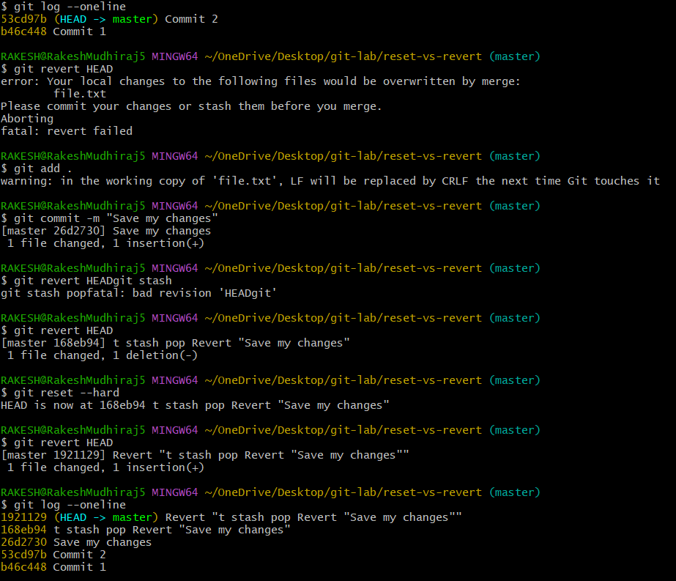

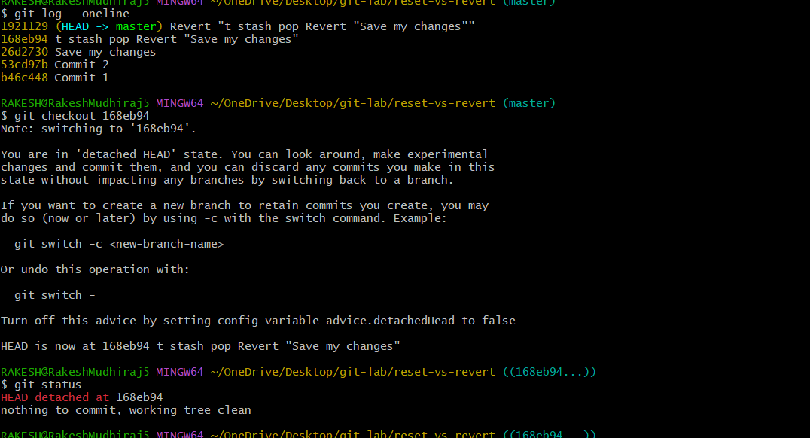

Git Hooks Challenge
- Configure a pre-commit hook to reject commits without a message format (e.g., must start with JIRA-XXX).
First we need to navigate to hooks folder
Create hook file
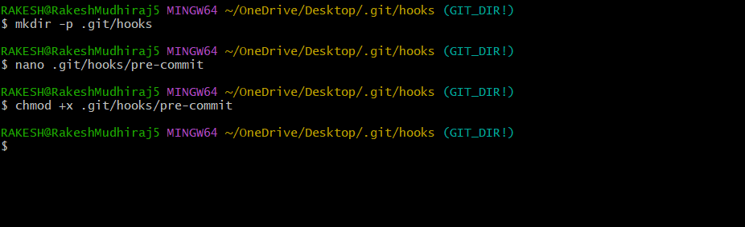



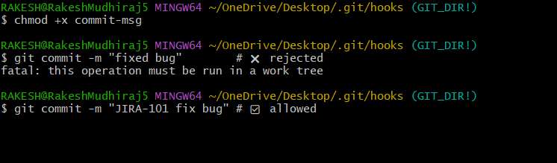
- Squash Merge vs Rebase Merge

Show the difference between squash merge and rebase merge with evidence.
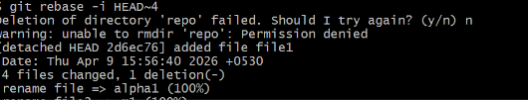
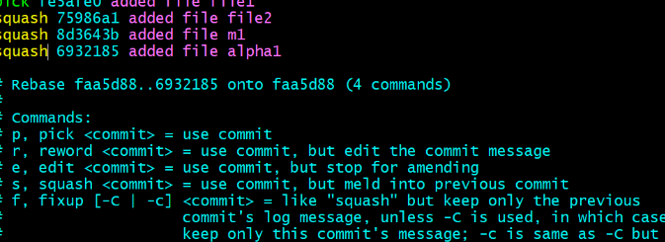

Fork & Pull Request Workflow
Fork a repo, make a change, and submit a pull request to the original repo.
